**24.1.1**

I worked on this all night. I planed per day. I designed per hour. Give it up!

What’s wrong?

**My pitch meeting with the Big Boss was terrible**

I’m sorry. What’s happen?

I’m not sure. **I listened when he talked**. **I asked all right questions.** **But he stopped me**. **He wanted me to start over**

I feel nervous

Everyone feel nervous when have to give a pitch to the Big Boss

Do we have everything we need?

I think so

Do you have you laptop, Khae?

**Yes, I remember it**. It’s right here

What’s wrong?

I think we missing something. Do you have a jacket?

I have the design, remember? Aanya, do you have it?

No, sorry. I can take in Marco office

When is a pitch?

2:30

It’s in 10 minutes

I look at the schedule. Remain top in our group. _ pitch at first, then Todd, and we go last

Marco, what are plan for the pitch meeting?

When I start turn, we stand up and walk to the front of the room. We say are name, then we say the name of product. After that, I can tell him about the product. When I finish, Aanya can told about make a product. Then Khae can show him the jacket, and told about why he need to choose our product. Are you Okay with that?

Yes, it’s a good plan. You go first, Aanya go second, and I go third

_. 1 2 3 _

Why was the employee not happy?

-> His meeting with the boos was bad

How does Khae feel?

-> She feels nervous

Aanay doesn’t have the jacket

Aanya can talk about making the product, and Khae cna talk bout why the boos needs to choose their product

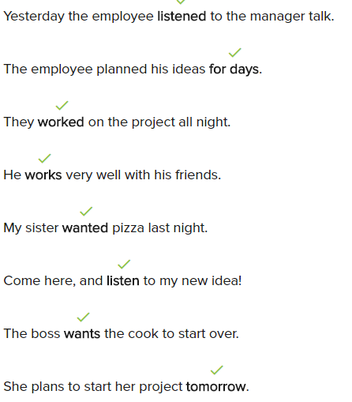

**Conversation**

Hi Richard, how was your weekend?

Hi Liz. It was good, but I worked on Saturday.

Oh, really? Why did you work on Saturday?

My boss asked me to design a new product.

I see. Did you work late?

No, I remembered that it was my sister’s birthday.

What did you do with your sister?

Well, she wanted a tennis game, but when I looked schedule, there wasn't tennis game until next year!

Oh, no. Was your sister sad?

Yes. She was little sad, so we walked in the park.

**Exercise**

I went to the beach last week.

I listened to my teacher yesterday.

I wanted to ask my friend to come tomorrow, but now he is out of town and I can’t.

I help with her homework when I can.

Last month, her parents were in Spain, but they decided to come home.

It rained on his way to work and now Jimmy needs to buy an umbrella after work.

His room was so messy yesterday!

-> Yes and it is today. It happens all the time!

Did you talk to your mother this morning?

-> Yes, I talked to her at breakfast.

I clean my apartment any night of the week.

24.1.2

My name is Rema. My product is banana cup

What does it do?

You put it on banana, then you can’t finish. **I ate half of this banana**, I’m full. But I don’t want to throw out banana. Oh there is my banana cup. Thank you!

I’m next! This is trouble we are have. What is right jacket to wear for the right situation? When you wear the right wear you reading books? You want to suit and jacket. When you wear a bus station going on the trip, you want other jacket. Or when you visit your sick grandma in a hospital, you wear a bring your nice jacket. Why catch one jacket be for everything. Now, I have a solution, the jacket can be anything

Interesting!

**That’s my idea! You took my idea!**

What?

That so lie, Sir. This is my idea. **I thought of it**. **I made it**

It’s a great idea. Tell me more!

**We had the idea first!**

We work so hard on it. How does he get our idea?

He saw on jacket design on Aanya’s desk and took them

**He told the Big Boss it was his idea**

We know it not. **I wanted to say something in the room**. **But I knew that was a bad idea**

I want to yell him

I want to punch him

What do you want to do?

There’s nothing we can’t do

No. We’re going to let Todd has a jacket product. Next him said it was his idea

We are?

What?

It was a good idea but we are going to think another idea

Todd’s product is a jacket to wear in any situation.

Todd’s product is the same as Khae’s product.

The Big Boss likes the jacket idea.

What does Khae want to do about the problem?

-> She wants to let Todd say it was his idea.

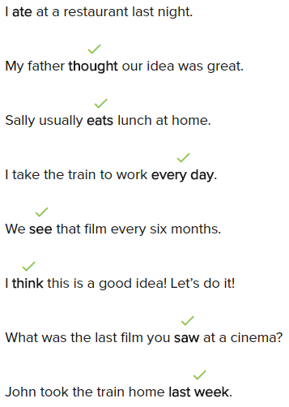

**Conversation**

Hi Henry. What did you do yesterday?

Hi Amanda. It was good day, because I took my grandma to the library.

That’s nice. What did you do after the library?

I wanted to the hospital with her. She needs to go every Saturday.

Oh, I see. What do you do after the hospital?

We ate lunch at her favorite dinner. It’s called Rosa’s Diner.

Where is Rosa’s Diner?

It’s behind the mall.

The mall uptown?

Yes, across the street from the bus station.

Oh, I think I know where is it. What did you have?

We had sandwiches. They was delicious.

**Exercise**

I made soup for dinner last night.

You can find many books at the library.

My sister and I love eating at that restaurant. Our father took us there as children.

Jerry thought that the new mall was open this week, but he was wrong.

You can buy a hat at the clothing shop.

You can look at the bus schedule and buy your ticket at the station.

When I get home in the evening, the first thing I do is take my shoes off.

I went to the hospital when I hurt my arm.

Mary and Ron told me they wanted to buy my old car.

24.1.3

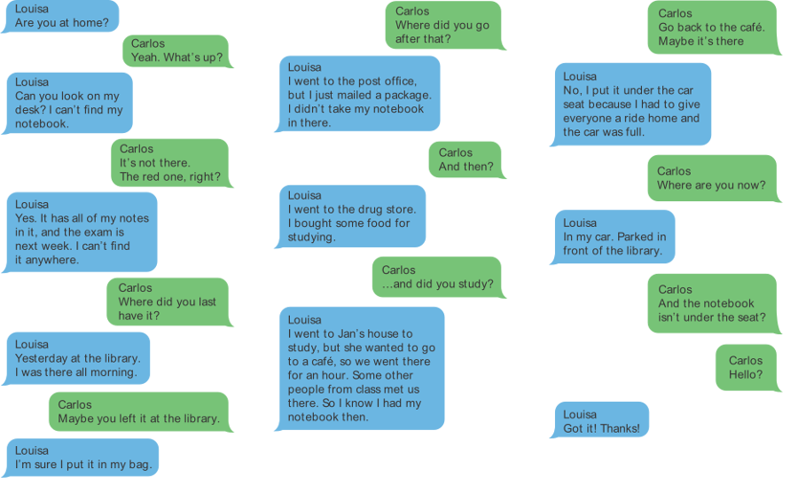

Louisa cannot find her notebook.

Where was Louisa yesterday morning?

-> At the library

Louisa bought some food for studying at the drug store.

Where did Louisa study with her class?

-> At a cafe

Carlos thinks the notebook is in Louisa’s car.

Louisa found the notebook under her seat.

**Practice**

He works at the hospital.

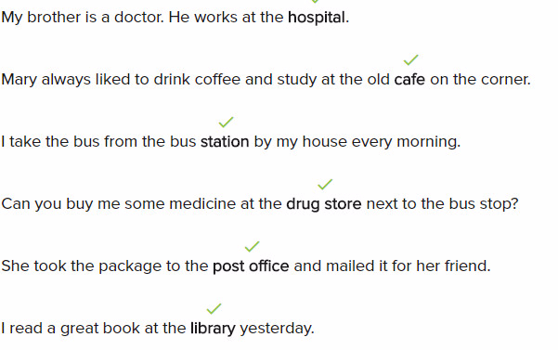

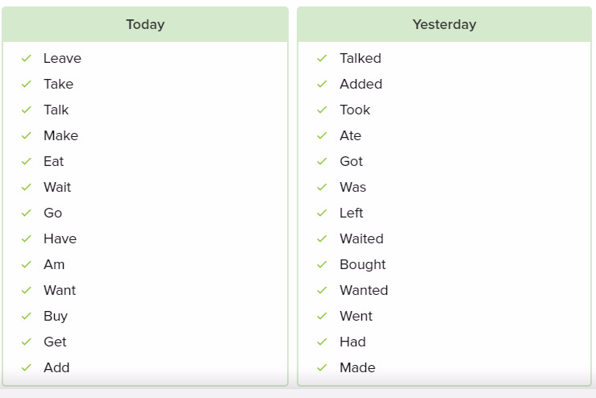













Exercise

Do you want to watch a movie tonight?

-> No, I told you last week. I have a meeting tonight.

You can read books for free at the library.

Ian always borrows his brother’s car on Friday nights and gives everyone a ride home.

You can look at the train schedule at the station.

I must finish my homework now.

Tyler made a cake last night.

You go to the hospital when you are sick.

Did you like the idea Rima talked about?

-> Yes, I thought was a good product.

**Lesson exercise**

Everyone listened when he talked.

I listened when he talked.

I ate half of this banana.

He works at the hospital.

We watched TV all day yesterday at home.

Dora takes her daughter to the library on Saturdays.

Jon ate chicken for lunch yesterday.

I saw an old friend at the park last weekend.

Dan was alone at the hospital, so I visited him last night.

We took the book to the library

He saw Yoon at the movies

We watched the weather on TV

My brother and I had fun at your party

Kasia looked everywhere for her phone

I ate lunch five minutes ago

I want to see you

When I got out of bed yesterday, I knew that most of my beach holiday was finished.

We went to that new restaurant and ate a great meal!

Terry listens to music when she is sad.

Jan told me yesterday that she wants to borrow my black skirt.

We had to take the 3:00 train into the city yesterday.

I borrow books from the library and I use the computers there, too.

The first buses leave the station early in the morning.

Can you go to the drug store and get me something for my cold?

Sometimes I bring my laptop to the cafe to work and drink coffee.

Our post office is always busy, so you have to go early to mail a package.

I had to go to the hospital last night because my stomach hurt a lot.

Work book

1/10

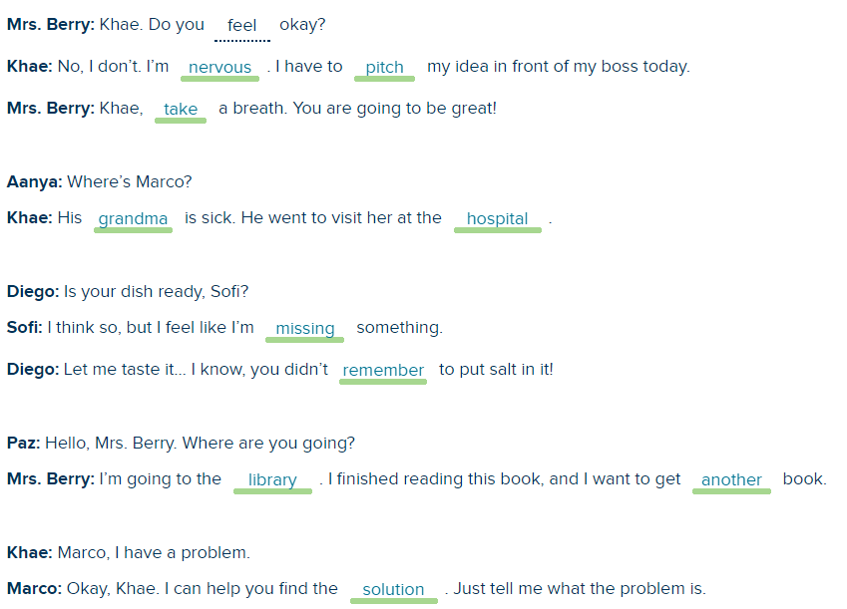

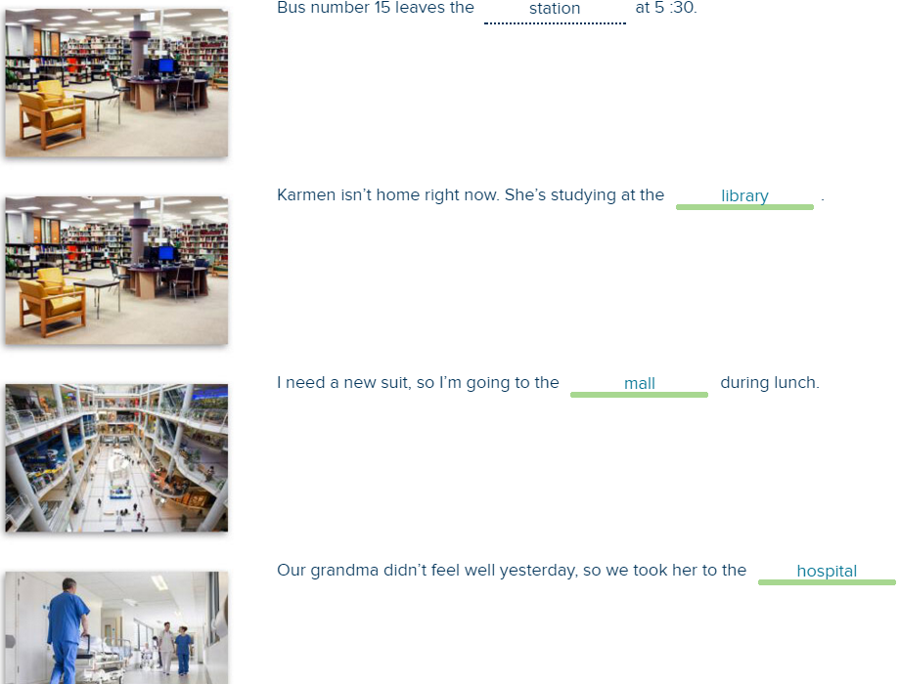

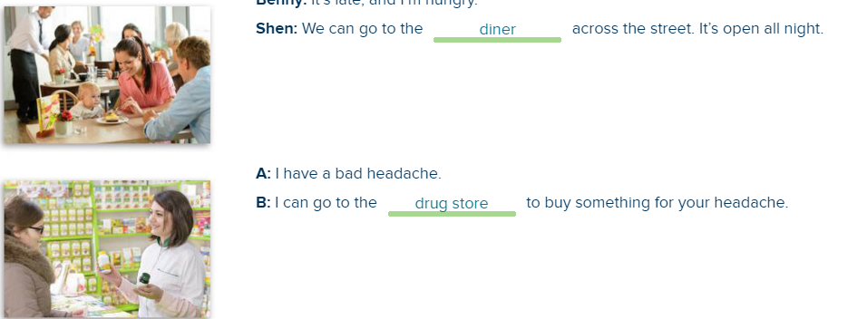

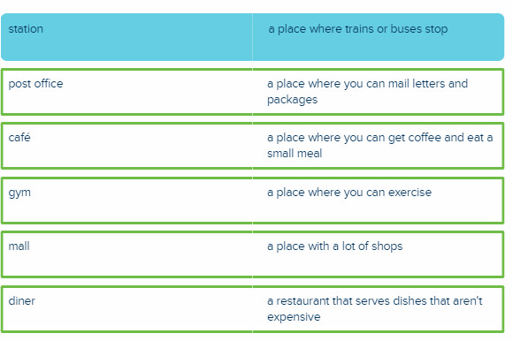

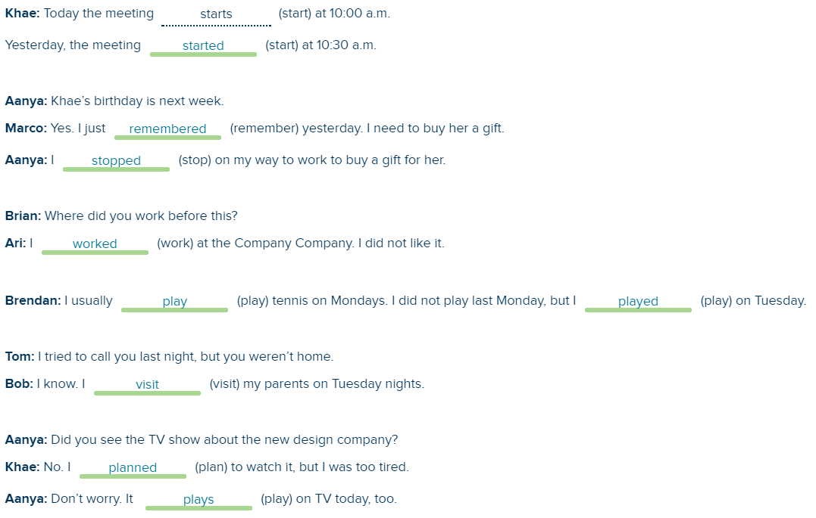

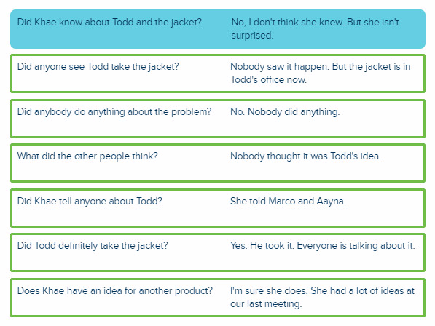

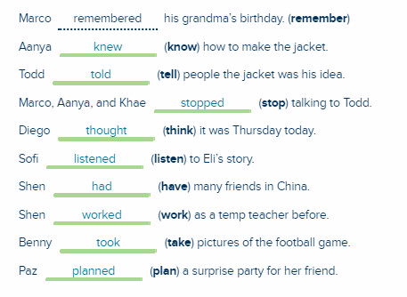

Tarek had a very strange day last week. First, he didn’t wear his pants in the morning! He was on the bus and looked down. He still had his pajama pants on! Later, he thought he saw his friend Amanda. He yelled her name, but it wasn’t Amanda. It was someone else. After work, Tarek wanted to go home, but he took a wrong bus! The bus took him far away from home. Tarek had to take the taxi back home. He stopped at a Chinese restaurant to buy some Chinese chicken. At home, he started eating the chicken, but it wasn’t chicken. It was beef! And it was spicy! Tarek made some eggs instead. He ate his eggs, but he wasn’t happy. He wanted chicken!

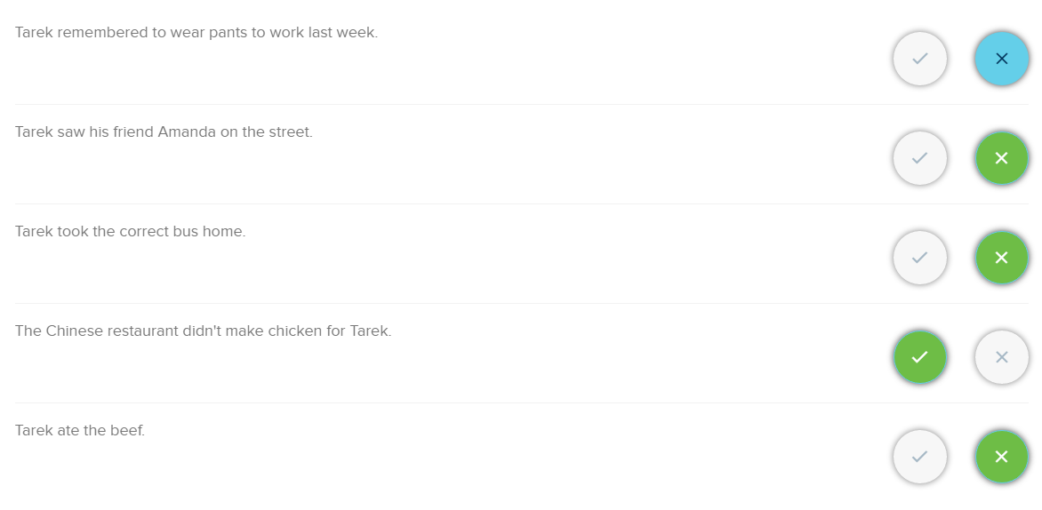

I worked on this all night.

I planned it for days.

I designed it for hours.

I ate half of this banana.

He saw our jacket designs on your desk and took them.

We had the idea first.

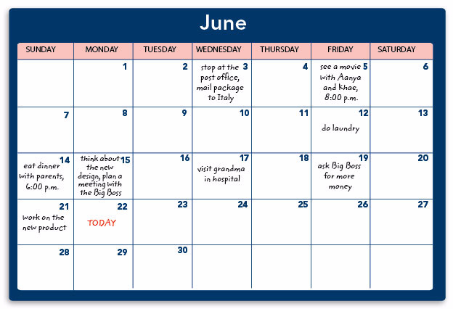

What did Marco do on June 3rd?

Marco stopped at the post office and mailed a package to Italy.

What did Marco do on June 5th?

Marco saw a movie with Aanya and Khae.

What did he do on June 14th?

He ate dinner with his parents.

What did he do on June 15?

He thought about the new design and planned a meeting with Big Boss.

What did he do on June 19th?

He asked Big Boss for more money.

When I was 9 and my sister was 11, we were at a summer camp. It was a beautiful place right near the beach. I loved swimming and riding horses. I made a lot of nice friends. I took swimming lessons and I ate a lot of good food. I had a great time. I thought it was the best summer. But my sister didn’t have a good time. She missed our parents very much. She didn’t like the food. She didn’t make any friends. She didn’t want to take swimming lessons. She was sad all the time. A few years ago, my sister and I found the letters we wrote. My letters said, "I love everything. I am having a great time." My sister’s letters said, ”I am not happy. I want to come home.” Maybe we were at different camps!